CECS 461/561 Midterm 1 Study Guide

Study Materials
Lectures 1 - 4, reference materials listed at the end of each lecture, Labs 1 – 2.

Test Format
Close book, close notes for written test. Written test will be conducted online. Open book and notes for hands-on test.

Topics to review

Lecture 1 – Introducing Hardware/Software Codesign

- Embedded systems design trend: fully hardware-and-software programmable systems vs. developing hardware and software separately.
Old days:
Systems were built by using many discrete parts, such as FPGA, memory, and I/O, logic design tools from a variety of suppliers were used to specify their individual. The interfacing of the CPU to the logic, memory, and I/O systems is performed through the logic tools; The software side was implemented by using specialized tools for code and OS development; The hardware and software interfacing work is performed by using a combination of these tools and, in some cases, co-verification or co-simulation tools; functionalities as well as integrating them to function together; The CPU side of the product was most often discrete part.
Now:
Many of the logic functions became integrated into single devices, such as Virtex™ families from Xilinx; larger amounts of memory are still off-chip, but more memory became available as new families were introduced and densities increased; more of the logic design to be developed and implemented as a single unit rather than as discrete parts that required additional interfacing; merging much of the discrete functionality into a single part is now reality; unlocking the full potential of fully hardware-and-software programmable systems, both as an end product and as an advantageous development process, requires a coupling of the silicon, the hardware and software IP, and the development tools into a cohesive unit of parts and design solutions.
- The evolution for embedded systems design tools: Page 6.
- Terminologies: SoC, SoPC, IP, soft core (soft IP), hard core (hard IP),
- Hardware design process for SoPC: Page 8.
- Compare two different SoC platforms: ASIC and SoPC.
- SoPC design tool chain: Page 9
- Embedded system design flow for Zynq-7000 AP SoC: Page 12
- Xilinx Vivado hardware/software codesign components: Page 10

Lecture 2 – Embedded Systems Design Using Zynq
- Zynq is Xilinx’s new generation of All-Programmable System-on-Chip (SoC), a processing element that can be applied to anything. Zynq devices are intended to be flexible and form a compelling platform for a wide variety of applications.
- Definition of Zynq: combines 1 dual-core ARM Cortex-A9 processor with traditional FPGA: the ARM Cortex-A9 is an application processor, capable of running full operating systems such as Linux; the programmable logic is based on Xilinx 7-series FPGA architecture with industry standard AXI interfaces.
- Advantages of SoC over System-on-a-Board: lower cost, enables faster and more secure data transfers between the various system elements, has higher overall system speed, lower power consumption, smaller physical size, and better reliability.
- Describe the two main parts in an APSoC (All-Programmable SoC) and their inconnection between the two: Processing System (PS) formed around a dual-core ARM Cortex-A9 processor, and Programmable Logic (PL), which is equivalent to that of an FPGA. AXI interfaces are the links between the PL and PS.
- Describe how the overall functionality is partitioned between hardware and software: PL: implementing high-speed logic, arithmetic and data flow subsystems on the FPGA, PS: supports software routines and/or operating systems.
- Embedded System Design Architecture in Zynq: it is based on the following three major parts:
  - Generating hardware platform: including processor and peripherals design, i.e., the Dual ARM Cortex-A9 processors, AXI interconnect, and AXI interconnect peripherals.
  - Generating software platform (Board Support Package): including standalone/OS, C language support, Processor services, C driver for hardware.
  - User application
- Five major steps in FPGA-based embedded system design using Vivado:
Step 1: Create a project using Vivado
Step 2: Create PS and PL using IP Integrator
Step 3: Generate Top-Level HDL and Export to SDK
Step 4:
Create a Software Application in SDK
Step 5:
Verify Functionality in Hardware

- Review Lab 1 for building an embedded system with basic PS.

Lecture 3 – Extend Embedded System into PL with Vivado

- The Zynq-7000 AP SoC architecture consists of two major sections: Page 3.
- PS (Processing system): including dual ARM Cortex-A9 processor based multiple peripherals, and hard silicon core.
- PL (Programmable logic): Uses the same 7 series programmable logic, based on the following two FPGA fabrics, Artix™-based devices and Kintex™-based devices.
- List some components in PS: Page 4
- The concept of APU, major components in APU. Page 5
- Major components in PS: programmable logic to memory, central interconnect, peripheral master/peripheral slave, processing system master/processing system slave. Page 7, 8
- Which component(s) in PS communicate with PL: Processing system master/Processing system slave, Page 9.
- PS-PL Interface AXI -- Advanced eXtensible Interface: AXI interconnect form a bridge between PS and PL. Two types of AXI4: AXI4-Lite, AXI4-Stream, Page 10.
- Interconnect vs. interface: Page 11
- Understand AXI general-purpose ports (GP0-GP1) used in the lab: two masters from PS to PL, two slaves from PL to PS; 32-bit data width; Conversation and sync to processing system clock domain: PL Clock and reset sources: Four PS clock outputs to the PL with enable control. Page 14.
- The concept of Simulation, Synthesis, and Implementation in hardware design. Page 15.

Lecture 4 – AXI GPIO
- The AXI GPIO is a 32-bit peripheral that interfaces to an AXI4-Lite interface that provides a general purpose input/output feature.
- Optional interrupt request generation and capable of dual channels.
- Do we use difference IPs to access the onboard dip-switch and push button in Lab 2? No. Same IP, different instances of the IP.
- When building software application project for an embedded system using Vivado SDK, three projects will be built in the following order: hardware platform, software platform (including board support package), software application.

Hands-on Highlight: Review Lab 2 on the steps for creating GPIO instances, configuring the instance, generate bitstream, expert to SDK and using drivers to access them.

Review Questions

True/False Questions:
- With the advent of the Platform FPGA and SoC ASICs, merging much of the discrete functionality into a single part for is now reality. T
- Embedded design in an FPGA consists of the following: FPGA hardware design, C drivers for hardware, Software design. T
- In a Soft IP core a full custom VLSI layout for the processor is placed in the FPGA. F
- The two main parts in an APSoC (All-Programmable SoC) is Processing System (PS) formed around a dual-core ARM Cortex-A9 processor, and Programmable Logic (PL), which is equivalent to that of an FPGA. T
- The interconnection between the PS and PL is the AXI interfaces. T
- Two types of AXI4 are AXI4-Lite and AXI4-Stream. T
- When using Xilinx Vivado SKD design embedded systems, you may create only one software application for each of your hardware platforms. F
- The AXI GPIO is a 32-bit peripheral that interfaces to an AXI4-Lite interface that provides a general purpose input/output feature. T
- When building software application project for an embedded system using Vivado SDK, three projects will be built in the following order: hardware platform, software platform (including board support package), software application. T
- The AXI GPIO provides dual channels. T
- An interconnect is effectively a switch which manages and directs traffic between attached AXI interfaces. T
- An interface is a point-to-point connection for passing data, addresses, and hand-shaking signals between master and slave clients within the system. T

Multiple Choices Questions:
- The following is a list all steps involved in FPGA-based embedded system design using Vivado. Please find out the second step.
  - Verify Functionality in Hardware
  - Create a project using Vivado
  - Generate Top-Level HDL and Export to SDK
  - Create PS and PL using IP Integrator
  - Create a Software Application in SDK
Answer: d
- Which one of the following file maintains the description for the software platform of your embedded system?
  - HDF
  - MSS
  - MPD
  - MDD
  - None of the above
Answer: b
- Which one of the following file maintains the description for the hardware platform of your embedded system?
  - HDF
  - MSS
  - MPD
  - MDD
  - None of the above
Answer: a
- Which one of the following is not a component in a BSP?
  - IP Drivers
  - Library functions
  - Application software
  - Processor functions
  - None of the above
Answer: c
- After export the hardware platform to SDK and launch SDK, from which one of the following files you can find the information for the hardware platform of the system?
  - MSS
  - HDF
  - UCF
  - ELF
  - None of the above
Answer: b
- Verifying the functionality of a hardware design is done in which one of the following step:
  - Simulation
  - Synthesis
  - Implementation
  - None of the above
Answer: a
- Implementing a hardware design by translating the design into a next level of abstraction: from RTL level to gate level, is done in which one of the following step:
  - Simulation
  - Synthesis
  - Implementation
  - None of the above
Answer: b
- Translating netlist into the placed and routed FPGA design is done in which one of the following step:
  - Simulation
  - Synthesis
  - Implementation
  - None of the above
Answer: c
- The dual ARM Cortex-A9 processors reside in which one of the following components in PS?
  - Central interconnect
  - Peripheral master
  - Processing system master
  - APU
  - Programmable logic to memory
Answer: d

- Which one of the following statement on memory-mapped I/O is NOT true?
  - In memory-mapped I/O method, we use the same address bus to address both memory and I/O devices.
  - In memory-mapped I/O method, we make control registers and I/O device memory appear to be part of the system’s main memory.
  - The CPU instructions used to access the memory are also used for accessing devices.
  - In order to accommodate the I/O devices, areas of the CPU's addressable space must be reserved for I/O.
  - None of the above
Answer: e
- Which one of the following hardware components in the block diagram generated in Lab 2 for hardware platform is a hard core?
  - processing_system7_0
  - processing_system7_0_axi_periph
  - rst_ processing_system7_0_100M
  - switches
  - buttons
Answer: a
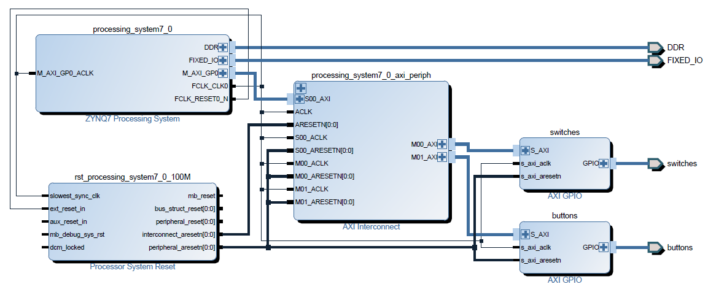

Prepare Hands-on Test for Midterm 1:

- Make sure you have a working Lab 1 with no extra design in your Lab 1.
- Finish the following practice before Midterm 1: Save Lab 1 as PracticeMidterm1, add three GPIO instances: one to control the onboard dip switch, one to control the push button and a third one to control the onboard LEDs. Implement the following features: each dip switch controls the on/off of the corresponding LED, each push button flashes the corresponding LED.

